Chapter 3: The English Colonies in America
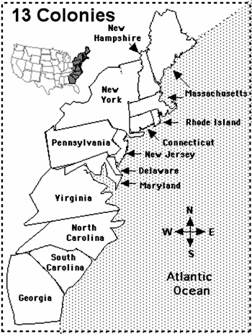 |  | Northern:
 |  | Middle:
 |  | Southern:
Government in the colonies
What was a charter?
What does it mean to be self-governing?
What was a general assembly and how was it formed?
Were the colonies democratic? Why or why not?

